TICKET INTELLIGENCE
The Holy Grail
Administrator & User Documentation · v1.0 · Team Tier · March 2026

Overview
Ticket Intelligence is an AI-powered knowledge engine built natively into Jira. The moment a new issue is opened, it surfaces similar past incidents, identifies who has resolved them before, assembles expert war rooms, and prevents duplicate work — all without leaving Jira.

Built on Atlassian Forge, Ticket Intelligence runs entirely within Atlassian's infrastructure. Your ticket data never leaves your cloud boundary for processing — a critical differentiator for enterprise security teams.

Team Tier Capabilities
- Semantic similar issue matching with TI Score confidence breakdown
- AI analysis — root cause, resolution steps, recommended contact
- Similar issue prevention — automatic comment within seconds of ticket creation
- Duplicate detection at 88%+ confidence
- Slack and Microsoft Teams war room assembly — one click from incident to war room
- P1 → GitHub / GitLab tracking issue auto-creation
- Datadog, Sentry, and Linear alerting webhooks
- Confluence runbook surfacing
- Knowledge Graph — domain expertise map derived from resolution history
- Agent assignment stub — automated fix workflow with human approval
- Mark as resolved flywheel — improves future matches
- FinOps controls — daily usage caps per org

Quick Start

Minimum Setup (5 Minutes)
Ticket Intelligence works out of the box with no connector configuration. The core panel requires only the app installation.

- Install Ticket Intelligence from the Atlassian Marketplace on your Jira instance.
- Open any Jira issue. The Ticket Intelligence panel appears automatically in the issue view.
- The panel runs a semantic search against your org's resolved ticket history and the Ticket Intelligence public corpus of resolved engineering incidents.
- Click RUN INTELLIGENCE ANALYSIS to get AI-generated root cause, resolution steps, and recommended contact.

On first install, your org's ticket history has not been indexed yet. The daily sync runs automatically and indexes your resolved tickets within 24 hours. You can also trigger a manual sync at any time from Settings → Sync now.

If the panel does not appear automatically, click the customise layout icon (⚙) on the issue view and add Ticket Intelligence from the available panels.

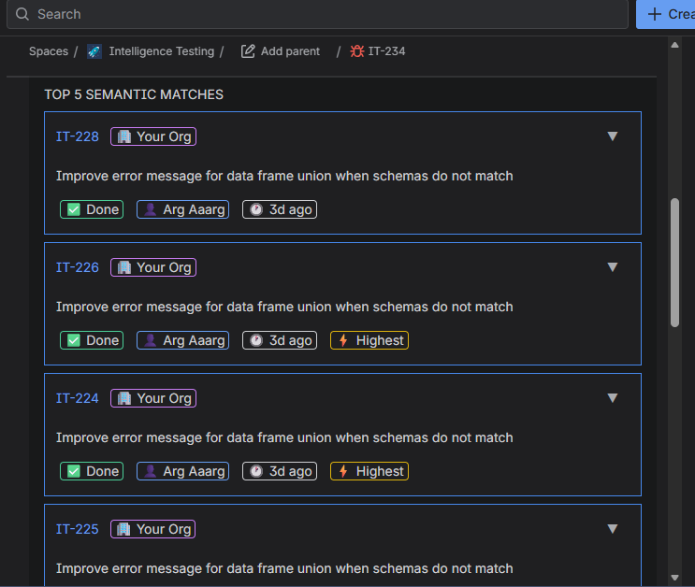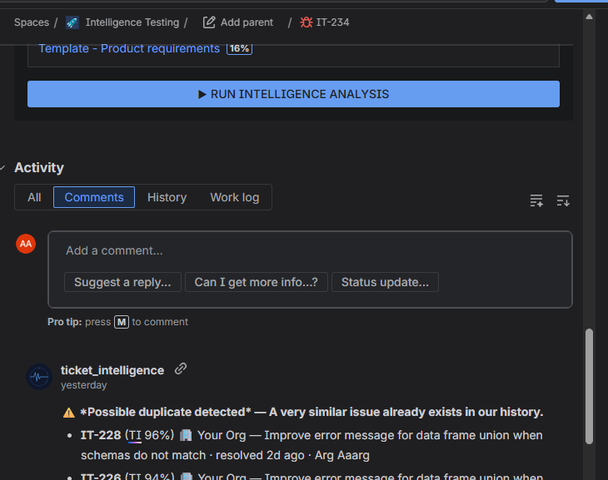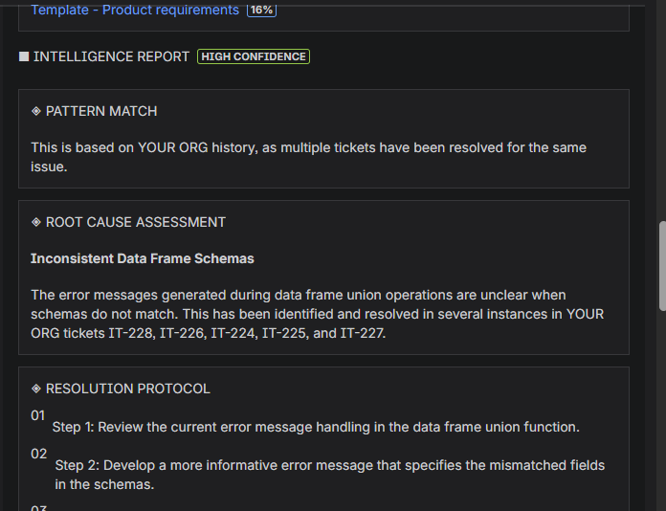

Settings
Access Settings at: Apps → Ticket Intelligence → Settings

The Settings page is divided into sections. Each connector is independent — configure only the tools your org uses. A Sync now button at the top triggers a manual knowledge base sync immediately.

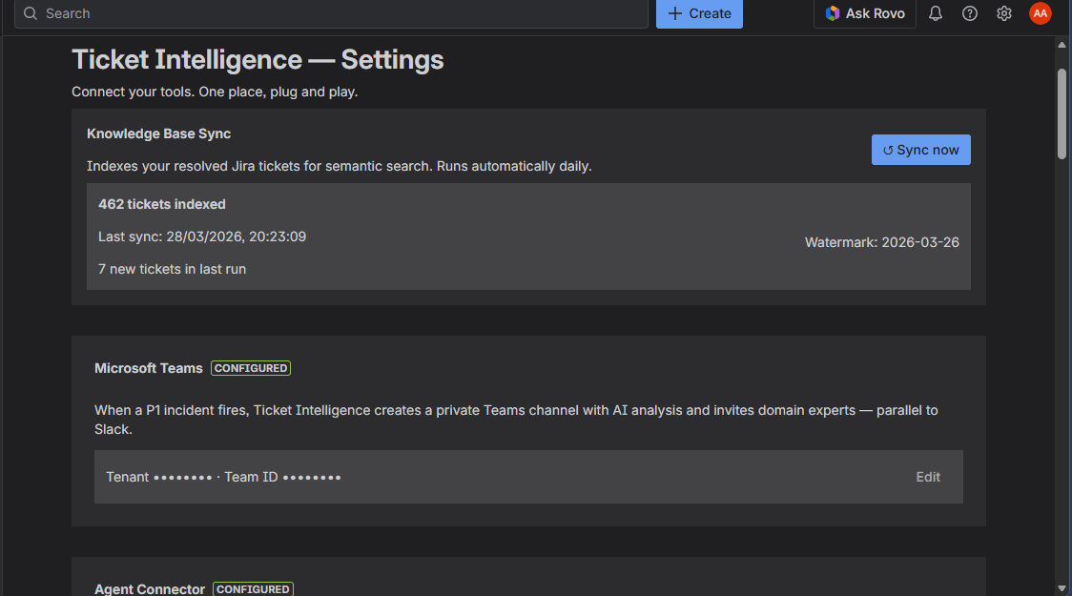[ SCREENSHOT: Settings page — top section with Sync now button ]

GitHub Connector
When a new GitHub issue is opened in your configured repository, Ticket Intelligence posts an AI analysis comment automatically. When a P1 Jira issue is created, a tracking issue is automatically opened in your repo with TI analysis pre-filled.

Prerequisites
- A GitHub organisation admin must install the Ticket Intelligence GitHub App on your organisation
- The app must be granted access to at least the repository used for P1 tracking issues

Installing the GitHub App
- Go to the Ticket Intelligence GitHub App install page: https://github.com/apps/ticket-intelligence/installations/new
- Sign in to GitHub if prompted
- Select your GitHub organisation
- Choose which repositories to grant access to — select All repositories or specific repos
- Click Install
- After installing, note the Installation ID from the URL: github.com/settings/installations/YOUR_ID

The Installation ID is the number at the end of the URL after /installations/ — for example if the URL is github.com/settings/installations/3067890, the Installation ID is 3067890.

Configuration in TI Settings
- In TI Settings → GitHub Connector, enter the Installation ID
- Enter the P1 Tracking Repo in owner/repo format — e.g. my-org/backend
- Click Save

Important: The form stays open until you explicitly click Save. The connector will not show Connected until Save is clicked — do not close the page before saving.

You do not need to configure a private key, App ID, or webhook URL. These are managed by Ticket Intelligence and are not visible to customers.

[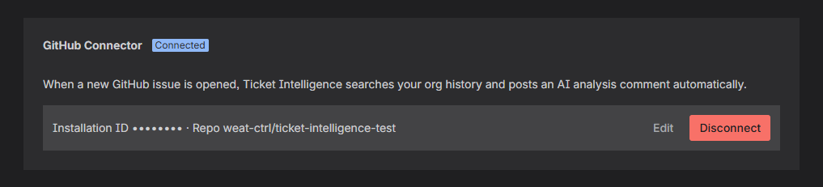 SCREENSHOT: GitHub Connector — connected state showing masked Installation ID ]

GitLab Connector
When a new GitLab issue is opened, Ticket Intelligence posts an AI analysis comment automatically. Works with GitLab.com and self-hosted instances.

Option A — Connect via OAuth (recommended)
- In TI Settings → GitLab Connector, click Connect GitLab
- Sign in to GitLab if prompted and authorise Ticket Intelligence
- You will be redirected back — refresh Settings to confirm Connected status

Option B — Manual Token
- Click Enter token manually instead in TI Settings → GitLab Connector
- In your GitLab project: Settings → Access Tokens → create a token with Developer role and api scope
- Paste the token, enter a Webhook Secret Token (any string you choose), and if using self-hosted GitLab enter your instance base URL
- Click Save. Your webhook URL is shown at the top of the GitLab section — paste it into GitLab project Settings → Webhooks using the same secret token, with Issues events enabled

Recent GitLab versions renamed Issues events to Work Item Hook. If Issues events is not visible, look for Work Item Hook.

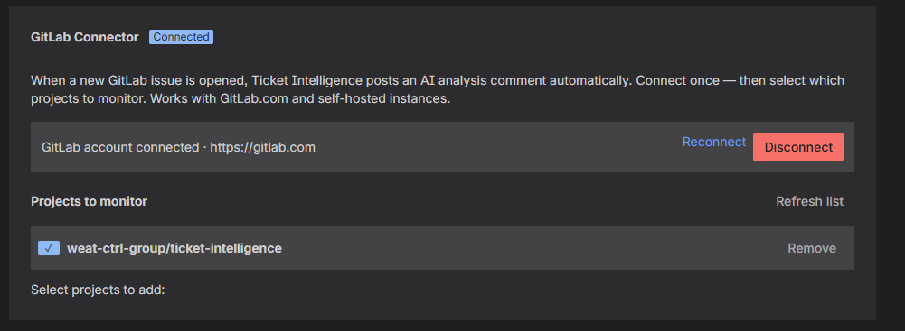[ SCREENSHOT: GitLab Connector — connected state ]

Slack — Assemble the Strike Team
When a P1/P2 incident or multi-domain issue is detected, a button appears in the Jira panel to instantly create a private Slack war room, invite domain experts, and post an AI briefing as the first message.

Option A — Add to Slack (recommended)
- In TI Settings → Slack, click + Add to Slack
- Select your Slack workspace and authorise Ticket Intelligence
- You will be redirected back — refresh Settings to confirm Connected status

Option B — Manual Bot Token
- Click Enter token manually instead in TI Settings → Slack
- Go to api.slack.com/apps → Create New App → From scratch
- Name it Ticket Intelligence and select your workspace
- Go to OAuth & Permissions → Bot Token Scopes. Add: channels:manage, groups:write, chat:write, users:read, users:read.email
- Click Install to Workspace. Copy the Bot User OAuth Token (starts with xoxb-)
- Paste the token into TI Settings → Slack → Save

Alert Channel (Optional)
Enter a channel ID to receive a heads-up notification when a war room is being assembled. Find the channel ID by right-clicking a channel in Slack → View channel details.

The Ticket Intelligence bot must be invited to the alert channel before it can post. Run /invite @Ticket Intelligence in the channel.

Finding War Room Channels
War room channels are private and do not appear in the main channel list. To find them, search for ti-{issue-key} in Slack and look under Direct messages / Private channels in the results.

[ SCREENSHOT: Slack — Connected state ]

Microsoft Teams
Creates a private Teams channel with AI briefing and expert invitations in parallel with Slack. Requires an Azure AD app registration by your IT or Azure administrator.

Azure AD App Setup
- Go to portal.azure.com → Azure Active Directory → App registrations → New registration
- Name it Ticket Intelligence. Leave the redirect URI blank.
- Go to API permissions → Add a permission → Microsoft Graph → Application permissions
- Add: Channel.Create, ChannelMember.ReadWrite.All, ChannelMessage.Send, Team.ReadBasic.All, User.Read.All
- Click Grant admin consent for your organisation
- Go to Certificates & secrets → New client secret. Copy the Value (not the ID).
- Note the Application (client) ID and Directory (tenant) ID from the Overview page

Finding Your Team ID
In Microsoft Teams, click the three dots next to the Team → Get link to team. The Team ID is the groupId parameter in the URL.

Configuration
- In TI Settings → Microsoft Teams, enter Tenant ID, Client ID, Client Secret, and Team ID
- Click Save

Teams credentials are stored encrypted in Forge Storage and are never logged or transmitted outside Microsoft's authentication endpoint.

[ 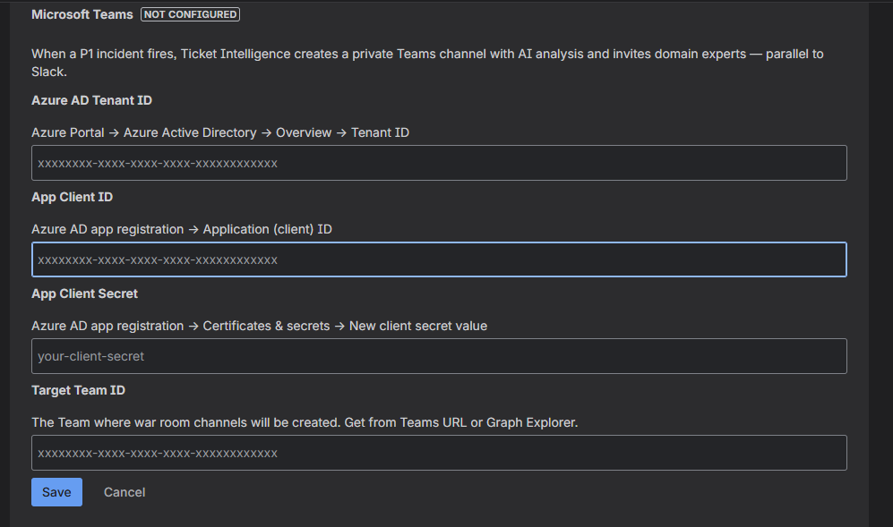SCREENSHOT: Microsoft Teams — configuration fields ]

Datadog / Sentry / Linear Alerting
When a Datadog monitor fires, Sentry captures a new issue, or Linear creates an issue, Ticket Intelligence automatically creates a Jira ticket with similar past incidents and resolution steps pre-filled.

Webhook URLs
Your webhook URLs are shown at the top of the Datadog / Sentry Alerting section in Settings. Copy and paste the relevant URL into each service — no CLI setup required.

[ S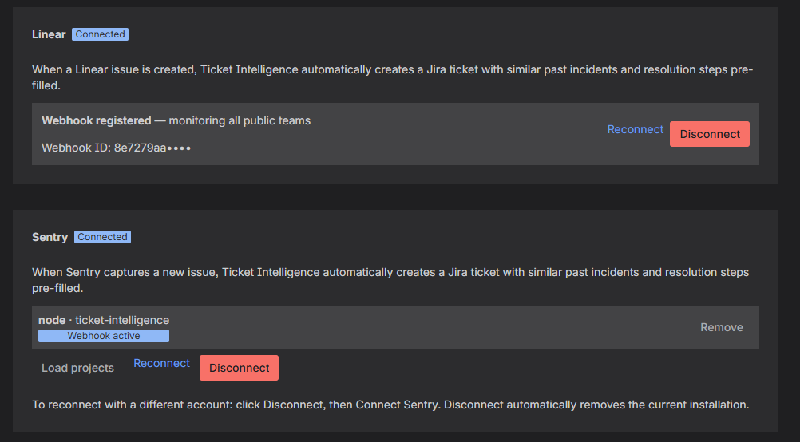CREENSHOT: Alerting section — pre-built webhook URLs for each service ]

Sentry — Connect via OAuth (recommended)
- In TI Settings → Datadog / Sentry Alerting, click Connect Sentry
- Authorise Ticket Intelligence in Sentry
- Refresh Settings to confirm Connected status
- Click Load projects, select the projects to monitor, and click Add selected projects

If Connect Sentry shows "Integration already installed", click Force reconnect first to clear the previous installation, then connect again.

Sentry — Manual Setup (API Token)
- Click Configure manually instead in TI Settings → Sentry
- In Sentry → User Settings → API Tokens → Create New Token
- Set scopes: Organization: Read and Project: Read
- Paste the token into TI Settings → Sentry → Connect
- After connecting, TI Settings will show your webhook URL. In Sentry, go to Settings → Developer Settings → Internal Integrations → Create New Integration. Set the Webhook URL to the URL shown in TI Settings, enable issue events under Webhooks, and set Issue & Event to Read under Permissions. Save the integration.

Sentry personal API tokens do not expire. Once configured, no reconnection is needed.

Linear — Connect via OAuth (recommended)
- In TI Settings → Datadog / Sentry Alerting, click Connect Linear
- Authorise Ticket Intelligence in Linear
- Refresh Settings to confirm Connected status

When Ticket Intelligence creates a Jira ticket from a Linear issue, Linear automatically sends a notification to the reporter. The loop closes back in Linear without any manual action.

Linear — Manual Setup
- Click Configure manually instead
- In Linear: Settings → API → Webhooks → Create webhook
- Set the callback URL to your Linear webhook URL shown in Settings. Enable Issues events. Copy the signing secret.
- Paste into TI Settings → Linear Webhook Secret → Save

Datadog — Setup
No account connection required — paste two values into Datadog and you're done.
- In TI Settings, note your Datadog webhook URL
- In Datadog: Integrations → Webhooks → New
- Set URL to your Datadog webhook URL shown in Settings
- Replace the default payload with the template shown in TI Settings
- In any Datadog monitor → Notify your team → add @webhook-YourWebhookName

Datadog does not require a shared secret — the webhook URL is cryptographically unique per installation and cannot be guessed.

Jira Project for Auto-created Issues
Set the Jira Project for Auto-created Issues to the project key where alert-triggered tickets should be created (e.g. IT, OPS, INFRA).

Confluence Runbooks
Ticket Intelligence automatically surfaces related Confluence pages alongside similar incident matches. If your Jira and Confluence are on the same Atlassian site, no additional setup is required — the app detects Confluence automatically once installed on Jira.

If runbooks are not appearing, verify that:
- Ticket Intelligence is installed on your Confluence site — go to Apps → Explore more apps → search Ticket Intelligence → install
- Your Confluence pages are in a space that the app has permission to search
- The issue you're viewing has enough context for a semantic match against your Confluence content

Agent Connector
Register an agent endpoint to enable automated fix suggestions. When a similar issue was previously resolved by an agent, or TI Score confidence exceeds the threshold, the panel offers Run automated fix (requires approval).

Human approval is always required. The agent does not act autonomously. The button dispatches a request — a human must review and approve before any changes are made. Credit is always attributed to the human who originally resolved the similar issue.

Configuration
- In TI Settings → Agent Connector, enter the Agent name (e.g. Claude Code, Devin)
- Enter the Agent endpoint URL — Ticket Intelligence will POST the issue key, title, URL, and TI analysis to this URL when the approval button is clicked. Your organisation controls what service receives this data.
- Set the Minimum TI Score threshold (default 80%) — the agent option only appears when top match confidence exceeds this value
- Click Save. Use the Test connection button to verify the endpoint responds correctly.

Important: The form stays open until you explicitly click Save. Do not navigate away before saving.

[ 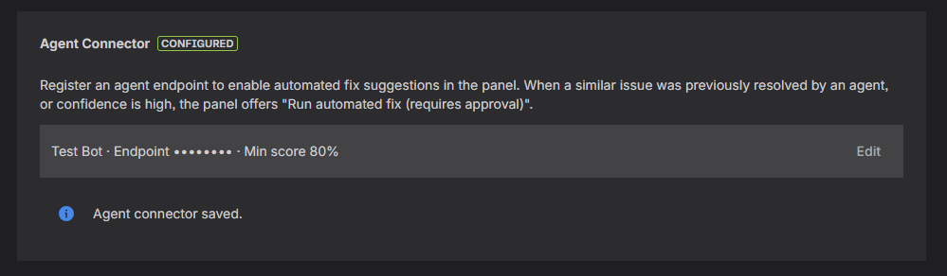SCREENSHOT: Agent Connector — configured state with Test connection button ]

User Guide

The Ticket Intelligence Panel
The Ticket Intelligence panel appears automatically in the Jira issue view. It runs a semantic search the moment you open an issue — no button click required for the initial matches.

If the panel does not appear automatically, click the customise layout icon (⚙) on the issue view and add Ticket Intelligence from the available panels.

[ SCREENSHOT: Full panel overview on a matched issue ]

Status Bar
Shows total tickets indexed, last sync date, and average resolution time for similar issues.

TOP 5 SEMANTIC MATCHES
The five most semantically similar resolved tickets from your org history and the Ticket Intelligence public corpus. Each match shows:
- Ticket key and summary
- TI Score — composite confidence score (semantic similarity, recency, source quality, resolution quality)
- ▼ Score breakdown — expand to see individual score components
- Source badge — Your Org or TI Corpus
- Resolution status, resolver name, and relative date

RELATED RUNBOOKS
Confluence pages semantically related to the current issue, shown with match percentage and excerpt. Requires Confluence to be connected.

RUN INTELLIGENCE ANALYSIS
Click to generate AI analysis using your org's historical data:
- PATTERN MATCH — whether this issue has been seen before, with confidence level
- ROOT CAUSE ASSESSMENT — most likely root cause based on similar incidents
- RESOLUTION PROTOCOL — numbered steps derived from past resolutions
- RECOMMENDED CONTACT — who to call, based on who resolved similar issues

On a novel issue with no close matches, the confidence will be Low and the analysis will note it is based on the public corpus only — not your org's history.

ASSEMBLE STRIKE TEAM
Appears on P1/P2 issues or when multiple domain experts are identified. Creates a private Slack or Teams channel with all identified experts auto-invited and the AI briefing as the first message.

War room channels are private. Search for ti-{issue-key} in Slack to find them — they will not appear in the main channel list.

[ 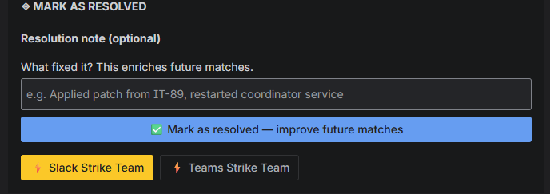SCREENSHOT: Panel showing ASSEMBLE STRIKE TEAM buttons — Slack and Teams ]

MARK AS RESOLVED
After running analysis, add an optional resolution note and click Mark as resolved — improve future matches. This writes the resolution back to your org's knowledge base, improving future matches for similar issues.

Automated Fix
When an agent endpoint is configured and a high-confidence match is found, a Run automated fix (requires approval) button appears. Clicking it dispatches the issue context to your registered agent. A human must review and approve before any changes are applied.

Knowledge Graph
The Knowledge Graph shows domain expertise derived automatically from your org's resolution history. Access it from your Jira project board → top nav → More → Knowledge Graph.

Each expert card shows:
- Total resolved tickets
- Top domain (e.g. Authentication, Payments, Infrastructure)
- Activity bar — relative volume compared to the top resolver
- Human-verified count — resolutions explicitly confirmed via the Mark as resolved flywheel
- ▼ Show all domains — expands to the full domain breakdown

The Knowledge Graph is a domain expertise map, not a performance metric. Rankings reflect who has resolved similar issues historically. Use it to find the right person to contact during an incident. It is never intended for use in performance reviews.

[ SCREEN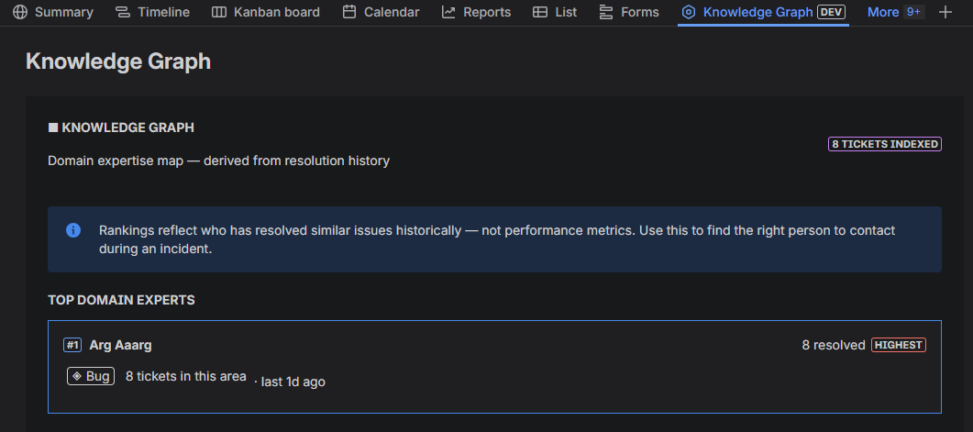SHOT: Knowledge Graph — expert cards with domain breakdown expanded ]

Similar Issue Prevention
When a new Jira issue is created, Ticket Intelligence automatically searches for similar past incidents and posts a comment within seconds. No action is required from the person creating the ticket.

The comment includes:
- Top 3 matches with TI Scores, source badges, resolver names, and relative dates
- Possible duplicate detected warning when the top TI Score exceeds 88%

TI stays silent when no strong matches exist — the comment only appears when at least one match exceeds 72% TI Score.

[ SCREE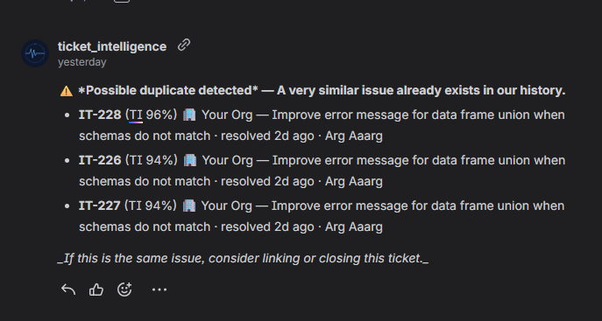NSHOT: Similar issue prevention comment on a newly created ticket ]

FinOps Controls
Administrators can set daily usage caps to manage API costs. Access from Settings → FinOps Controls. Today's usage is displayed in real time and resets at midnight UTC.

- Daily embed cap — max OpenAI embedding calls per day (default 500). Each similar ticket search = 1 call.
- Daily Pinecone query cap — max vector queries per day (default 1000).
- Daily AI analysis cap — max AI analysis calls per day (default 100). Each RUN INTELLIGENCE ANALYSIS click = 1 call.

When a cap is reached, the panel shows a clear message: Daily limit reached (500/500). Resets tomorrow.

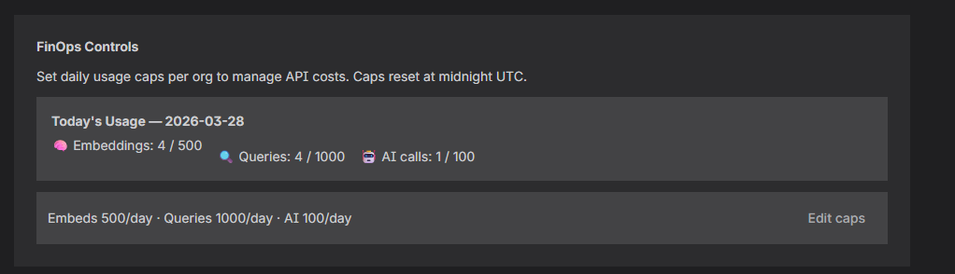[ SCREENSHOT: FinOps Controls — today's usage and cap configuration ]

Data Sync

Automatic Daily Sync
Ticket Intelligence runs a daily sync to index your org's resolved Jira tickets. The sync runs automatically at midnight UTC and is incremental — only new or updated tickets are processed.

Manual Sync
To trigger a manual sync at any time, go to Settings and click Sync now at the top of the page. The sync queues in the background — your tickets will be indexed within a few minutes.

What Is Indexed
- Resolved tickets from your Jira project (status: Done, Resolved, or Closed)
- Fields: summary, description, resolution, assignee, labels, priority, issue type
- Confluence pages (if Confluence is connected)

What Is Not Indexed
- Open or in-progress tickets
- Comments
- Attachments

Privacy & Security

Data Storage
All connector credentials are stored encrypted in Atlassian Forge Storage, managed by Atlassian. They are never logged by Ticket Intelligence.

External Services
- OpenAI API — issue text is sent for vectorisation. Not used to train OpenAI models under the API data usage policy.
- Pinecone — vector embeddings and ticket metadata stored for semantic search, scoped per organisation.
- Slack — issue key, title, and AI analysis sent when assembling a war room. Bot token stored encrypted in Forge Storage.
- Microsoft Teams / Graph API — issue key, title, and AI analysis sent for Teams war rooms. Azure credentials stored encrypted in Forge Storage.
- GitHub — AI analysis posted as a comment on issues. GitHub App private key stored as an encrypted Forge environment variable.
- GitLab — AI analysis posted as a note on issues. Access token stored encrypted in Forge Storage.
- Sentry / Linear — tokens stored encrypted in Forge Storage. Webhook secrets used only for signature verification.
- Agent endpoint (if configured) — issue key, title, URL, and TI analysis POSTed to the org-registered URL on button click. Your organisation controls what service receives this data.

Scope Summary
- read:jira-work — reading issue data for semantic search and analysis
- write:jira-work — posting prevention comments and auto-created alert tickets
- read:jira-user — looking up user emails for war room invitations (transient, never stored)
- search:confluence, read:confluence-content.all — surfacing related runbooks
- storage:app — storing connector configuration and usage data

Troubleshooting

Panel Not Appearing
- Click the customise layout icon (⚙) on the issue view and add Ticket Intelligence from the available panels
- Verify the app is installed — go to Apps → Manage apps and confirm Ticket Intelligence is listed

Panel Not Loading or Showing an Error
- Trigger a manual sync from Settings → Sync now and wait a few minutes
- Verify the app is fully installed. Go to Apps>Manage Apps and confirm Ticket Intelligence shows as Enabled
- If the error persists, contact support. Include your Jira site URL and a screenshot of the error message

No Matches Showing
- Your org's tickets may not be indexed yet — trigger a manual sync from Settings → Sync now
- Check that resolved tickets exist in your Jira project
- On first install the index is empty — matches improve significantly after the first sync

GitHub Connector Not Saving
The GitHub form stays open until you explicitly click Save. The Connected badge does not appear until Save is clicked. Do not navigate away before saving.

Slack War Room Not Creating
- Verify the Slack connector shows Connected in Settings
- If connected via OAuth, try Reconnect via OAuth to refresh the token
- If using a manual token, verify it starts with xoxb- and the Slack app has channels:manage and groups:write scopes

Alert Channel Not Receiving Notifications
The Ticket Intelligence bot must be invited to the alert channel. Run /invite @Ticket Intelligence in the channel. The bot cannot invite itself.

GitHub Tracking Issues Not Creating
- Verify the GitHub App is installed on the target repository
- Confirm the Installation ID in Settings matches the number at github.com/settings/installations/YOUR_ID
- Verify the P1 Tracking Repo is in owner/repo format with no trailing slash

Similar Issue Prevention Comment Not Appearing
- The comment only fires when at least one match exceeds 72% TI Score — low-confidence matches are intentionally silent
- On first install with no indexed tickets, no comment will appear — trigger a manual sync and create a test ticket after

War Room Channels Not Visible in Slack
War room channels are private. Search for ti-{issue-key} in Slack and look under Direct messages / Private channels in the results. They will not appear in the main channel list.

Sentry Connect Shows "Already Installed"
Click Force reconnect in TI Settings → Sentry to clear the previous installation from Sentry's side, then click Connect Sentry again. Accept & Install will be active.

Knowledge Graph Is Empty
The Knowledge Graph is built from resolved tickets in your org's index. Trigger a manual sync from Settings → Sync now and wait a few minutes. If your org has few resolved tickets, the graph will be sparse until more resolutions are added via the Mark as resolved flywheel.

Confluence Runbooks Not Appearing
- Verify Ticket Intelligence is installed on your Confluence site — Apps → Explore more apps → install
- Confirm your Confluence pages are in spaces the app has permission to access

Ticket Intelligence · Team Tier Documentation · v1.0 · March 2026

